Hingna Road, Wanadongri, Nagpur - 441 110
NAAC A++
Ph.: 07104-237919, 234623, 329249, 329250 Fax: 07104-232376, Website: www.ycce.edu

Department of Computer Technology

Vision of the Department
To be a well-known centre for pursuing computer education through innovative pedagogy, value-based education and industry collaboration. Mission of the Department
To establish learning ambience for ushering in computer engineering professionals in core and multidisciplinary area by developing Problem-solving skills through emerging technologies.

Session 2025-2026

Vision: Dream of where you want. | Mission: Means to achieve Vision

Program Educational Objectives of the program (PEO): (broad statements that describe the professional and career accomplishments)
PEO1 | Preparation | P: Preparation | Pep-CL abbreviation pronounce as Pep-si-lL easy to recall
PEO2 | Core Competence | E: Environment  (Learning Environment) | Pep-CL abbreviation pronounce as Pep-si-lL easy to recall
PEO3 | Breadth | P: Professionalism | Pep-CL abbreviation pronounce as Pep-si-lL easy to recall
PEO4 | Professionalism | C: Core Competence | Pep-CL abbreviation pronounce as Pep-si-lL easy to recall
PEO5 | Learning  Environment | L: Breadth (Learning in diverse areas) | Pep-CL abbreviation pronounce as Pep-si-lL easy to recall

Program Outcomes (PO): (statements that describe what a student should be able to do and know by the end of a program)
Keywords of POs:
Engineering knowledge, Problem analysis, Design/development of solutions, Conduct Investigations of Complex Problems, Engineering Tool Usage, The Engineer and The World, Ethics, Individual and Collaborative Team work, Communication, Project Management and Finance, Life-Long Learning

PSO Keywords: Cutting edge technologies, Research

“I am an engineer, and I know how to apply engineering knowledge to investigate, analyse and design solutions to complex problems using tools for entire world following all ethics in a collaborative way with proper management skills throughout my life.” to contribute to the development of cutting-edge technologies and Research.

Integrity: I will adhere to the Laboratory Code of Conduct and ethics in its entirety.

Name and Signature of Student and Date
(Signature and Date in Handwritten)

Hingna Road, Wanadongri, Nagpur - 441 110
NAAC A++
Ph.: 07104-237919, 234623, 329249, 329250 Fax: 07104-232376, Website: www.ycce.edu

Department of Computer Technology

Vision of the Department
To be a well-known centre for pursuing computer education through innovative pedagogy, value-based education and industry collaboration. Mission of the Department
To establish learning ambience for ushering in computer engineering professionals in core and multidisciplinary area by developing Problem-solving skills through emerging technologies.

Session | 2024-25 (ODD) | Course Name | Web Technology Lab
Semester | 3 | Course Code | 23CT1301
Roll No | 67 | Name of Student | Rushikesh Bhondekar

Practical Number | PRACTICAL NO.8
Course Outcome | - Understand various internet technologies.  - Design the web pages using HTML and CSS.  - Implement the XML technology to store the data.  - Develop the interactive web pages using JavaScript.
Aim | [A] Write a program in JavaScript to demonstrate the use of While and For Loop.  [B] Write a program in JavaScript to demonstrate the use of Conditional Statements and Functions.
Problem Definition | 1[A]  - Use a for loop to print numbers from 1 to 5.  - Use a while loop to print numbers from 5 down to 1.  This will illustrate how both types of loops work in controlling the flow of repetition  1[B]  To create a JavaScript program that demonstrates the use of conditional statements and functions.  The program should:  - Define a function that takes a number as input.  - Use if-else conditions inside the function to check whether the number is positive, negative, or zero.  - Display the result accordingly.  This helps understand how conditions control program logic and how functions improve code structure.
Theory  (100 words) | [A] Theory: While and For Loop in JavaScript  Loops in JavaScript are control structures that allow repeated execution of a block of code as long as a specific condition remains true  . They help reduce redundancy and make programs more efficient.  - For Loop: Used when the number of iterations is known in advance. It includes three parts — initialization, condition, and increment/decrement. The loop runs until the condition becomes false.  - While Loop: Used when the number of iterations is not known beforehand. It continues execution as long as the condition evaluates to true.  Loops are essential in programming for performing repetitive tasks such as traversing arrays, generating patterns, or calculating repeated values.  [B] Theory: Conditional Statements and Functions in JavaScript  Conditional statements and functions are fundamental building blocks of JavaScript programming.  - Conditional Statements: These allow decision-making in programs. The if, else if, and else statements execute different blocks of code based on whether a condition is true or false. They help control the logical flow of a program.  - Functions: A function is a reusable block of code designed to perform a specific task. It can take input values (parameters), process them, and return a result.  By combining functions with conditional statements, JavaScript programs become modular, structured, and capable of dynamic decision-making.
Procedure and Execution  (100 Words) | Step for Implementation:  [A] While and For Loop  Steps for Implementation:  - Create an HTML file.  - Write JavaScript inside <script> tags.  - Use a for loop to print numbers 1–5.  - Use a while loop to print numbers 5–1.  - Display results using document.write().  Procedure:  Open the file in a web browser to see both loops printing numbers in forward and reverse order.  Execution:  The for loop executes with increasing order, and the while loop runs in decreasing order until the condition becomes false.  [B] Conditional Statements and Functions  Steps for Implementation:  - Create an HTML file with a <script> section.  - Define a function checkNumber(num).  - Use if–else statements to check if the number is positive, negative, or zero.  - Call the function with different numbers.  Procedure:  Save and run the file in a browser; observe outputs for each function call.  Execution:  The program executes conditions inside the function and prints whether the given number is positive, negative, or zero.
Procedure and Execution  (100 Words) | Code: 1[A]:-  !DOCTYPE html>  <html>  <head>  <title>While and For Loops</title>  </head>  <body>  <h2>While and For Loops in JavaScript</h2>  <button onclick="runLoops()">Run Loops</button>  <pre id="loopOutput"></pre>  <script>  function runLoops() {  let output = "";  // While loop  output += "While Loop:\n";  let i = 1;  while (i <= 5) {  output += i + "\n";  i++;  }  // For loop  output += "\nFor Loop:\n";  for (let j = 1; j <= 5; j++) {  output += j + "\n";  }  document.getElementById("loopOutput").textContent = output;  }  </script>  </body>  </html>  1[B]:-  <!DOCTYPE html>  <html>  <head>  <title>Conditional Statements and Functions</title>  </head>  <body>  <h2>Check if a Number is Positive, Negative, or Zero</h2>  <input type="number" id="numberInput" placeholder="Enter a number">  <button onclick="checkNumber()">Check Number</button>  <p id="result"></p>  <script>  function checkNumber() {  let num = parseInt(document.getElementById("numberInput").value);  let message;  if (num > 0) {  message = "The number is positive.";  } else if (num < 0) {  message = "The number is negative.";  } else {  message = "The number is zero.";  }  document.getElementById("result").textContent = message;  }  </script>  </body>  </html>
Procedure and Execution  (100 Words) | Output:-  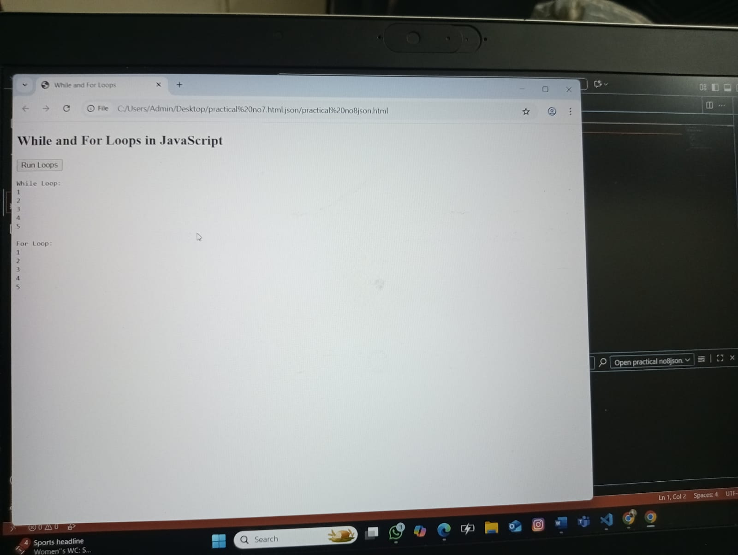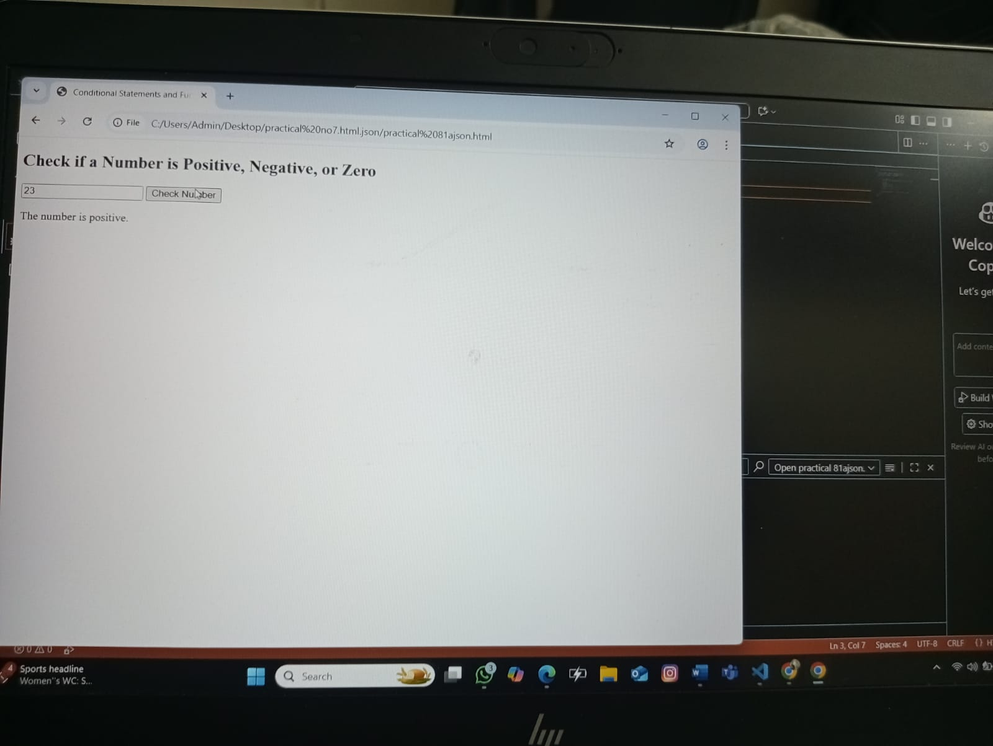
Output Analysis | [A] Output Analysis:  The for and while loops correctly display numbers in ascending and descending order, showing proper loop execution.  [B] Output Analysis:  The function accurately checks and displays whether the entered number is positive, negative, or zero using conditional statements.
Hingna Road, Wanadongri, Nagpur - 441 110
NAAC A++
Ph.: 07104-237919, 234623, 329249, 329250 Fax: 07104-232376, Website: www.ycce.edu

Department of Computer Technology

Vision of the Department
To be a well-known centre for pursuing computer education through innovative pedagogy, value-based education and industry collaboration. Mission of the Department
To establish learning ambience for ushering in computer engineering professionals in core and multidisciplinary area by developing Problem-solving skills through emerging technologies.

Link of student Github profile where lab assignment has been uploaded | https://github.com/rushikesh-bhondekar?tab=repositories
Conclusion | Both programs successfully demonstrate fundamental JavaScript concepts — loops efficiently perform repetitive tasks, while functions with conditional statements accurately make decisions based on input, showing proper program flow and logic.
Plag Report  (Similarity index <  12%) | 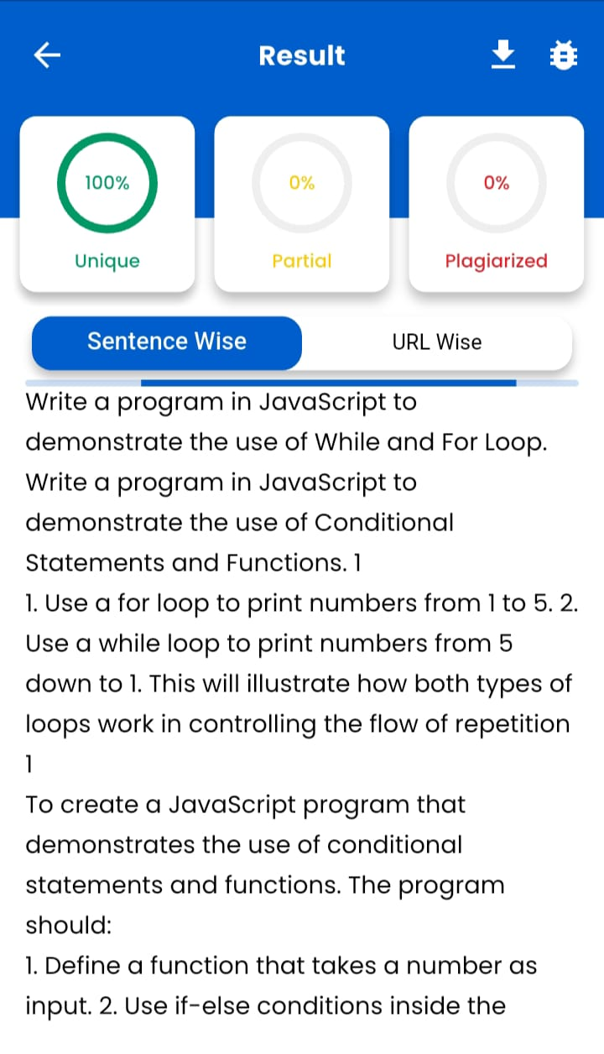
Date | 17/10/2025

